Project fail because:Poor planning,inadequate understand requirements, inadeq attention to quality,fail to respond to problems until too late.
Software project challenges
1.Feasibility and profitability.(Should the proj be done?)
2.Requirements.(What needs to be done)
3.Planning and controlling.(Who does what and when)
4.Implementation.(create the softw)
5.Delivery&maintenance(Deliver to users, respond to changes)
6.Support(Environment and tools needed for proj)
7.Teamwork(making sure everyone is on the same page)
Soft Devlpmt Life Cycle(SDLC): soft specification>soft Dev>soft validation>soft evolution
When is waterfall appropriate: Must get it right the first time;Cost of failure is very high;Complete and stable requirements.But hard to get it right the first time and changing requirements
Agile : frequent iter and deliv;Close collaboration between develper and customers;Support changing requir; Frequent retrospection (learn and improve from experience)
Why Agile: Big, upfront planning is not practical when the requirements is unstable and ambiguous; Deliver through small steps through iterative and incremental development to reduce risk; Customers are part of the team; frequent reflections about what are we doing well and what can be improved.
Motivation of Agile manifesto:Rational Unified Process(RUP) and Boehm’s risk exposure comparison.
Agile Manif:Individuals and interactions over processes and tools
Working software over comprehensive documentation;
Customer collaboration over contract negotiation;
Responding to change over following plan.
Principles of Agile:Satisfy the cust through frequent delivery;
Welcome changing requirements;Business people &dev work together;Motivated people working at sustainable pace; Face-to-face communication;Continuous attention to technical quality;Simplicity;Self-organizing teams;Regular reflection.
XP practices:1.The planning game; 2.Small releases; 3.Metaphor; 4.Simple design; 5Testing; 6Refactoring; 7Pair Programming; 8Collective ownership; 9Continuous integration; 10Sustainable pace; 10Whole team(customer is a member); 11Coding standard.
Compare Plan Driven and Agile (cooperate;1-4 is role of devlper)
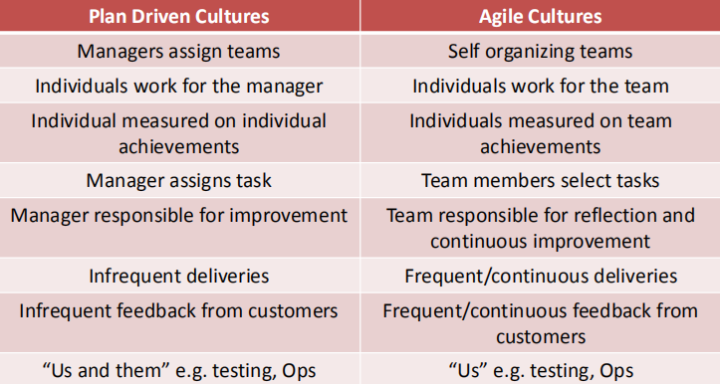
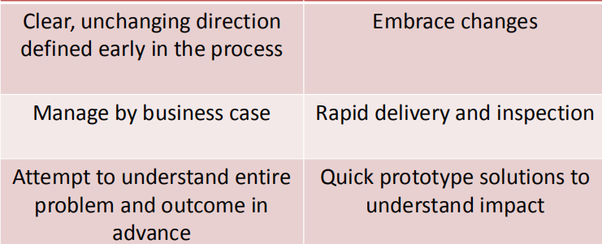
Role of executives
Role of manager
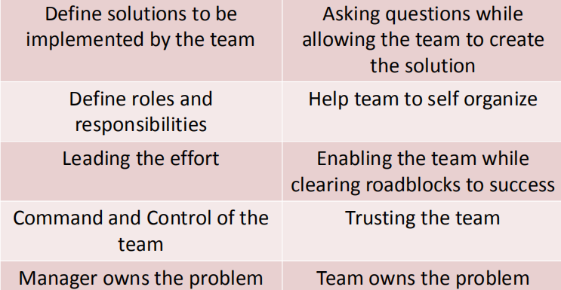
Why fail to trans from plan-driven to agile?
1.Lacking of clarity across the team.2.Using only worst of waterfall and Agile together.3.Forcing frequent short delivery without the agile advantage.4.Inadequate training or support for agile method. 5.fail to use automated testing and continuous integration. 6.Continue to plan everything in advance and not allowing change 7.Failing to change employee performance metrics8.Failing to inspect and adapt.
User case: Name,Brief description,Actors,Basic flow,Alternate flows
User Story:Title,Acceptance test,Priority,Story Points,Description.
Criteria for US: add value to customers; small enough; independent; testable; include non-functional requirements as US.
Product Owner:Represent the customer and cus’s needs.
Product visionary( what should the proj do?What are the features?Provides US.)Responsible for Return On Investment(ROI)
Communicate with Stakeholders.
Scrum Master:Healps the overall team to optimize their scrum process. He also protects the dev from outsiders and is the developers’ contact with the outside world.
Good backlog:US should be DEEP( Detailed Appropriately:High priority items have more detail; Emergent:allow frequent changes to meet changing needs; Estimated:Effort is estimated by dev; Prioritized:Current priority assigned by Prod Owner.)
Why features Locked:Dev have stability through the sprint,they can put all their effort into tasks and not have to worry about changing.
BurnDown chart:The purpose of a Burn-Down Chart is to predict when a project will be completed based on the current velocity of the team. The velocity is represented by slope of the line on a graph where x-axis is time and y-axis is remaining work.
Scrum is based on empiricism(who believe s that knowledge comes from experience and making decisions from what is known).Three pillars: Transparency, Inspection, Adaptation.
Testing: Unit;Integration;Regression;System;User Acceptance
Compare test in waterfall and Agile:1)Testing is blocked until development is “complete”;Testing is performed by a separate test team(Developers might not be trusted to test their own code)Testing schedule may be compressed if development schedule slips. 2)Testing is NOT a separate phase with Agile Methods(Instead, testing is integrated into every step)
Focus on automated testing and continuous integration(Find problems as quickly as possible. Expect frequent changes, so facilitate them)Challenge:inadequate coverage, frequent change.
Adv of continuous integration:1.find prob early and solve early.2.it facilitates frequent changes, suitable for agile.3.you know where you are. 4.Users get features more rapidly.4.reduce risk
BDD template: Given...When...Then...
Pair Program:driver&navigator, 15-20min, communicate,listen
PP behavior: P pressure, P negotiation,courage, review, debugging, learning, trust.
Best practice of Conti Integration: Maintain a single code repository.Fix broken builds immediately, Test in a clone of the production environment.etc
Deferred Integration happens in plan driven.Starts after all of the development happens. In CI, the build process is automated and happens during development so there is always a working product.

